# Customize Further: elif Statement in Python

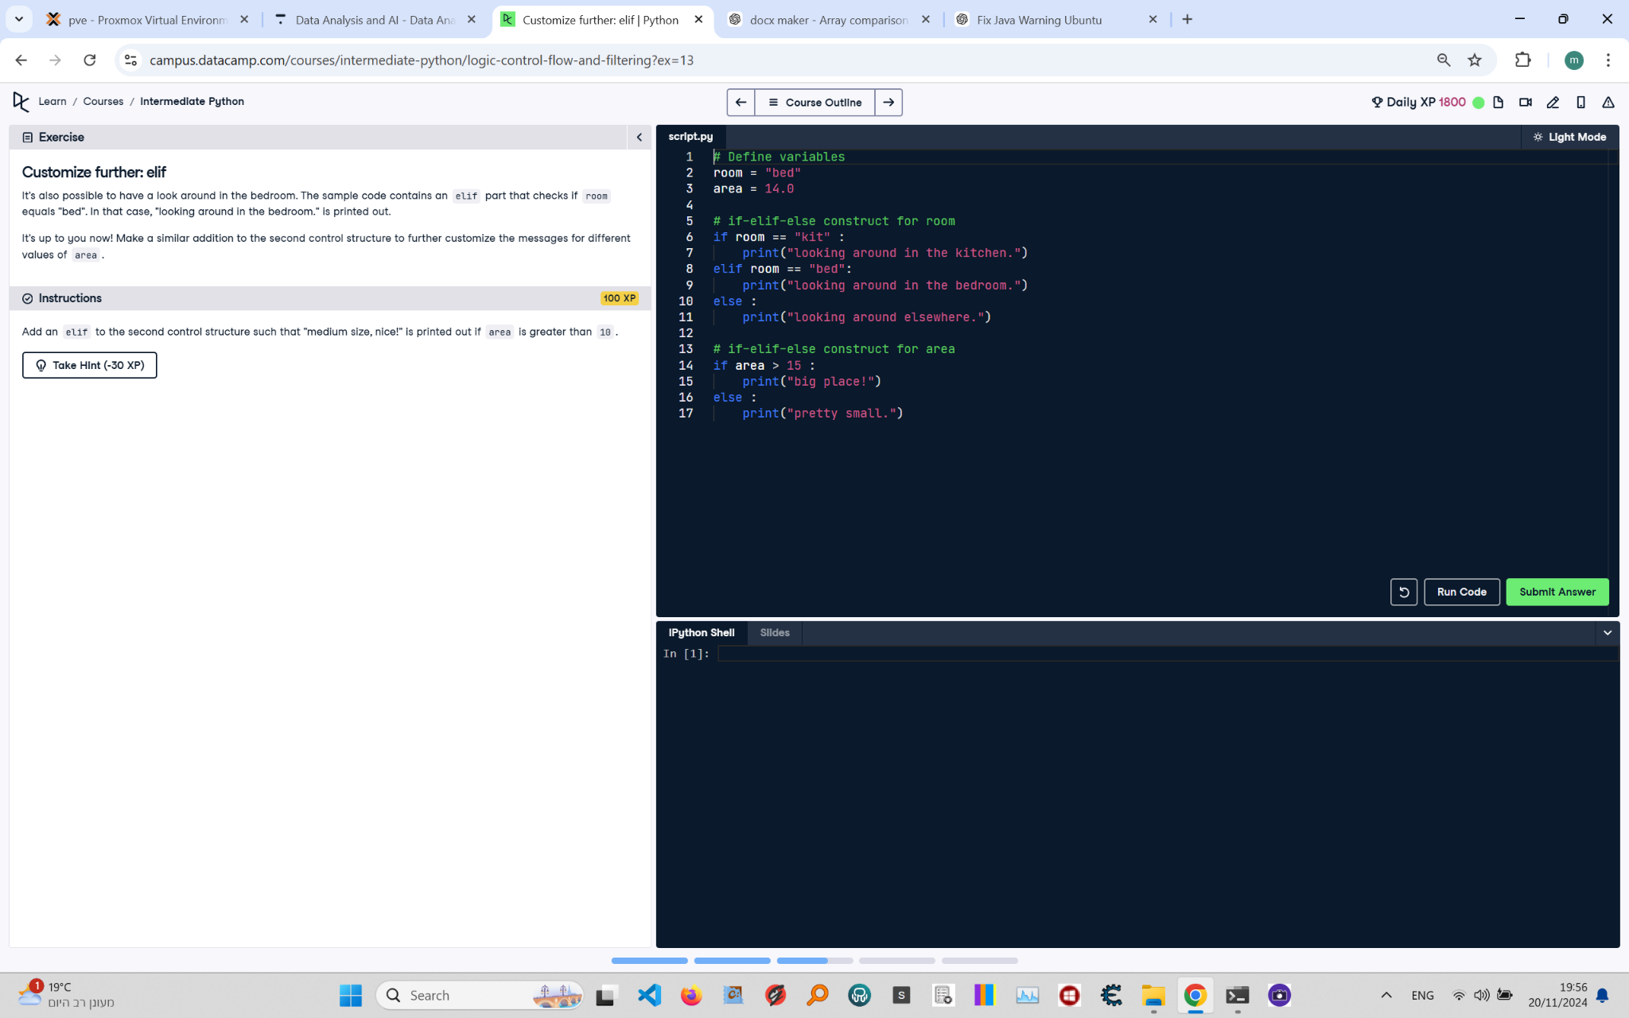

**Question:**

It's also possible to have a look around in the bedroom. The sample code contains an `elif` part that checks if `room` equals "bed". In that case, "looking around in the bedroom." is printed out.  
Make a similar addition to the second control structure to further customize the messages for different values of `area`.  
Add an `elif` to the second control structure such that "medium size, nice!" is printed out if `area` is greater than 10.

**Answer:**

Here is the Python code that solves the problem:

# Define variables  
room = "bed"  
area = 14.0  
  
# if-elif-else construct for room  
if room == "kit":  
 print("looking around in the kitchen.")  
elif room == "bed":  
 print("looking around in the bedroom.")  
else:  
 print("looking around elsewhere.")  
  
# if-elif-else construct for area  
if area > 15:  
 print("big place!")  
elif area > 10:  
 print("medium size, nice!")  
else:  
 print("pretty small.")

**Explanation:**

1. **Variable Initialization**: The `room` variable is set to "bed" and the `area` variable is set to 14.0.  
2. **First if-elif-else construct**: The `if` condition checks whether `room` equals "kit". If true, it prints "looking around in the kitchen." Otherwise, it checks the `elif` condition, which prints "looking around in the bedroom." if `room` equals "bed". If neither condition is satisfied, the `else` block executes and prints "looking around elsewhere.".  
3. **Second if-elif-else construct**: The `if` condition checks whether `area` is greater than 15. If true, it prints "big place!". If false, the `elif` condition checks whether `area` is greater than 10. If true, it prints "medium size, nice!". If both conditions are false, the `else` block executes and prints "pretty small.".